xBRC User Interface User Guide

**Revision History**

|  |  |  |  |
| --- | --- | --- | --- |
| **Rev** | **Date** | **Author** | **Description** |
| 1.0 | 5/1/2012 | Iwona Glabek | Release Version |
| 1.0 | 8/29/2012 | Steve Groth | Reviewed with edits |
| 1.0 | 10/1/2012 | Stephen Beecroft | Reviewed with edits |
| 1.4 | 10/2/2012 | Glenn Curtis | Updated to reflect xConnect 1.4 |

**Document Approvers & Sign-Off**

|  |  |  |  |
| --- | --- | --- | --- |
| **Date** | **Approver** | **Role** | **Document Accept/Reject** |
| 5/1/2012 | Ric Merrifield | Release Manager | Accept |
| 5/11/2012 | John Stiehl | Release Manager | Accept |

**Table of Contents**

1 Introduction 5

1.1 Purpose 5

1.2 Scope 5

1.3 Assumptions and Constraints 5

1.4 Definitions 5

2 Available Functionality 6

2.1 Location 6

2.1.1 Create Location 6

2.1.2 Edit Location 8

2.1.3 Delete Location 9

2.2 Reader 9

2.2.1 Create Reader 10

2.2.2 Edit Reader 11

2.2.3 Delete Reader 13

2.2.4 Unlink Reader 13

2.2.5 Link Reader 14

2.2.6 Enable Transmit Functionality 15

2.2.7 Disable Transmit Functionality 16

2.2.8 Add Band Transmit Command 18

2.2.9 Remove Band Transmit Command 20

2.3 Subway Diagram 21

2.3.1 Create Subway Diagram 22

2.3.2 Delete Subway Diagram 23

2.3.3 Delete Grid Item 23

2.3.4 Add Background Image 24

2.3.5 Remove Background Image 25

2.3.6 Show Subway Diagram on Facility View Page 25

2.3.7 Hide Subway Diagram on Facility View Page 25

2.4 Observe Guest Moving Through Attraction 26

2.5 Observe Guest Queue Simulation 26

# Introduction

Please note that throughout this document page names are highlighted in **bold** while page element names are in *italic*.

## Purpose

This document describes functionality available in xBRC UI.

## Scope

All xBRC UI screens are accessible from the xBRC UI **Home Page** <http://xBRC_IP:8090/UI>

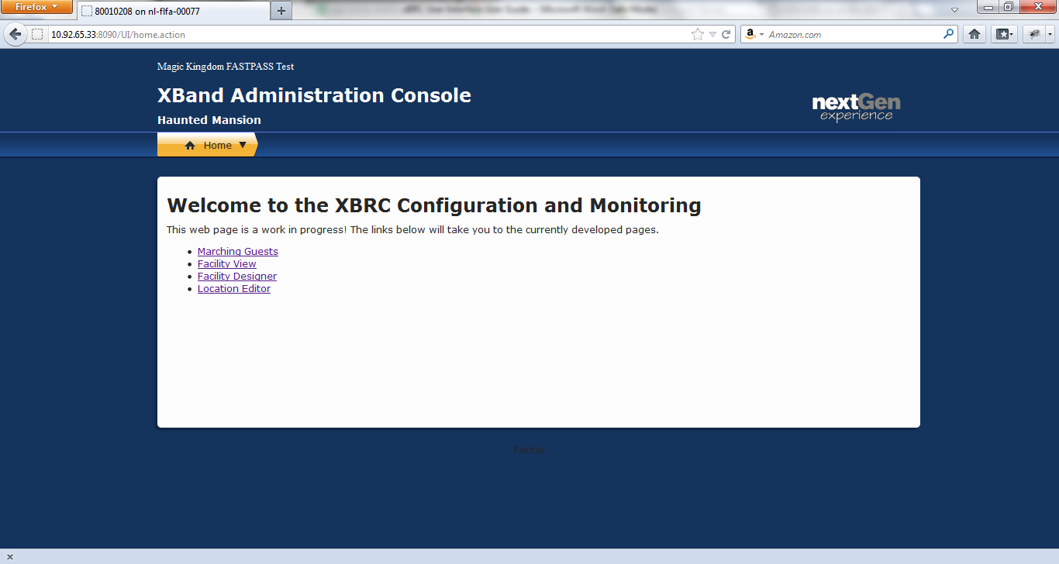

Figure 1: xBRC UI Home Page

## Assumptions and Constraints

For the first version of this application Mozilla Firefox is the recommended browser.

## Definitions

|  |  |
| --- | --- |
| **Terms** | **Definition** |
| xBRC | xBand Reader Controller |
| unassigned readers’ bucket | Set of readers that are not assigned to any location. |
| Grid items | Location and path elements available in the toolbox on the Facility Design page. |

# Available Functionality

## Location

All functionality related to Locations is accessible from the **Location Editor** page, reachable from the **Home Page**.

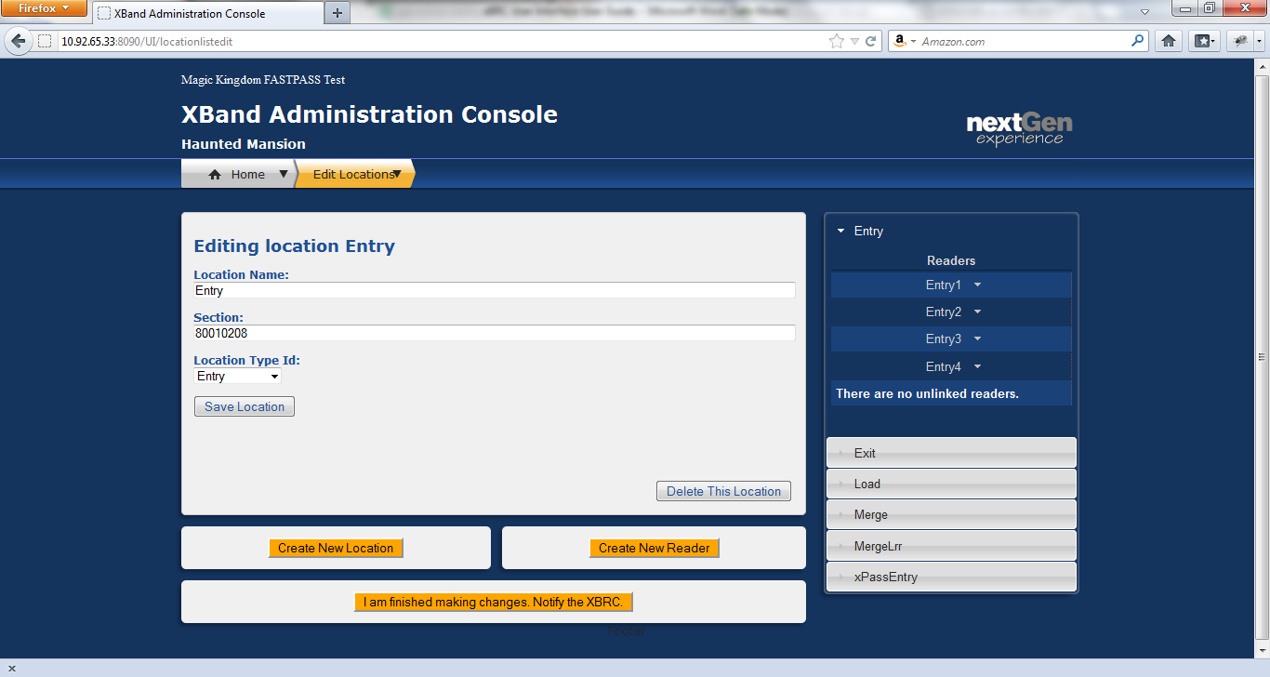

Figure 2: Location Editor Page

### Create Location

1. Navigate to the **Location Editor** page.
2. Click **Create New Location**. You will be taken to the **New Location** page.

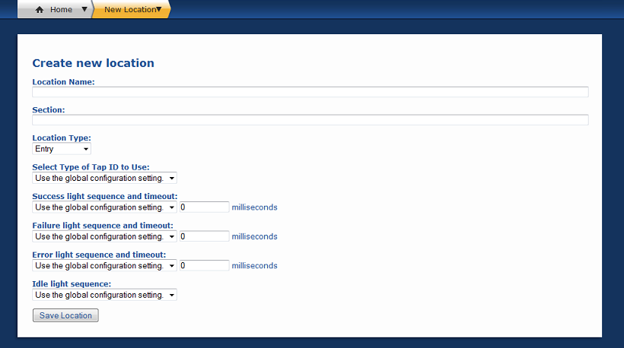

Figure 3: New Location Page

1. Provide the following values:

|  |  |
| --- | --- |
| **Field** | **Description** |
| *Location Name* | Alphanumeric string. |
| *Location Type* | Select appropriate type from the dropdown list. |
| *Section* | Required by GXP. If missing, DAP UI will not display this location. Venue id can be used, but any integer can also be used. |
| *Select Type of Tap ID to Use* | Type selected is communicated to xTP readers that use it to decide which ID to read off of a RFID media. |
| *Success light sequence and timeout* | Selecting the combination of lights and sounds to play on successful tap and for how long. |
| *Failure light sequence and timeout* | Selecting the combination of lights and sounds to play when a tap is rejected and for how long. |
| *Error light sequence and timeout* | Selecting the combination of lights and sounds to play on error and for how long. |
| *Idle light sequence* | Selecting the combination of lights and sounds to play continuously. Idle sequence is interrupted only by tap sequences. |

1. Click **Save Location**. You will be taken back to the **Location Editor** page and your new location will be saved in the database.
2. Click **I’m finished making changes. Notify the XBRC**to force xBRC to synchronize its state with the database.

### Edit Location

1. Navigate to the **Location Editor** page.
2. Select the location you wish to edit from the *accordion menu* on the right. The selected locations edit form will be loaded.

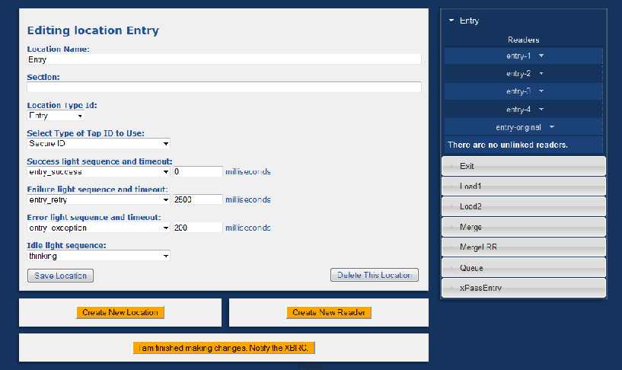

Figure 4: Edit Location Page

1. Make your changes. Refer to Create Location for descriptions of all these fields.
2. Click **Save Location**. Your change will be saved in the database.
3. Click **I’m finished making changes. Notify the XBRC**to force xBRC to synchronize its state with the database.

### Delete Location

When location is deleted, all readers previously associated with that location are moved to the unassigned readers’ bucket and all grid items associated with that location are deleted.

1. Navigate to the **Location Editor** page.
2. Select the location you wish to edit from the *accordion menu* on the right. The selected location’s edit form will be loaded.

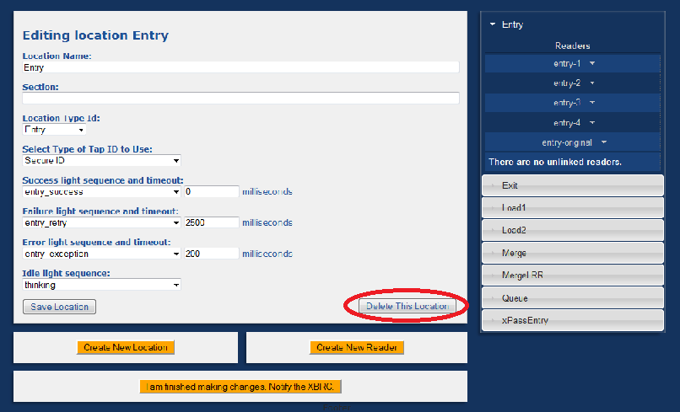

Figure 5: Edit Location Page-Delete Location

1. Click **Delete This Location**. Your change will be saved in the database.
2. Click **I’m finished making changes. Notify the XBRC**to force xBRC to synchronize its state with the database.

## Reader

All functionality related to Readers is accessible from the **Location Editor** page reachable from the **Home Page**.



Figure 6: Location Editor Page

### Create Reader

1. Navigate to the **Location Editor** page.
2. Click **Create New Reader**. You will be taken to the **New Reader** page.

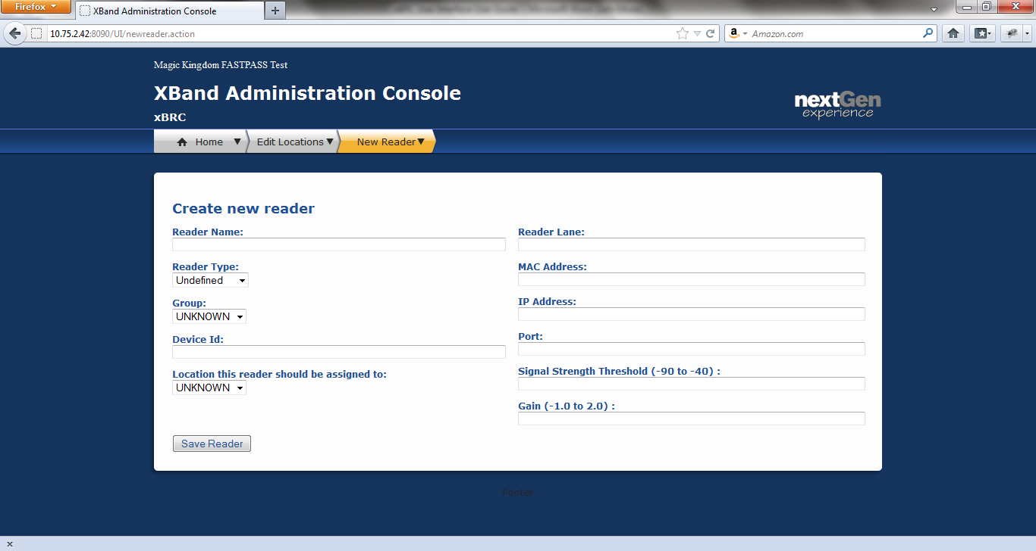

Figure 7: New Reader Page

1. Provide following information:

|  |  |
| --- | --- |
| **Field** | **Description** |
| *Reader Name* | Alphanumeric string. Do not use the ‘|’ (pipe) character. |
| *Reader Type* | Select appropriate type from the dropdown list. |
| *Group* | Leave as UNKNOWN. Not used. |
| *Device Id* | Identifies a reader uniquely across all xConnect systems. |
| *Location this reader should be assigned to* | Location this reader should be assigned to. |
| *Reader Lane* | An integer. Used at park entry. |
| *MAC Address* | Physical device’s MAC address. |
| *IP Address* | Physical device’s IP address. |
| *Port* | Physical device’s port number. |
| *Signal Strength Threshold* | Bands broadcasting at signal strength weaker than this signal strength will be ignored by this reader. |
| *Gain* | Signal strength multiplier. Should be set to one initially. |

1. Click **Save Reader**. You’ll be taken back to the **Location Editor** page and your new reader will be saved in the database.
2. Click **I’m finished making changes. Notify the XBRC**to force xBRC to synchronize its state with the database.

### Edit Reader

1. Navigate to the **Location Editor** page.
2. From the *accordion* menu on the right, select the location of the reader you wish to edit and then select that reader.
3. From the reader menu that appears, select **Edit***.*

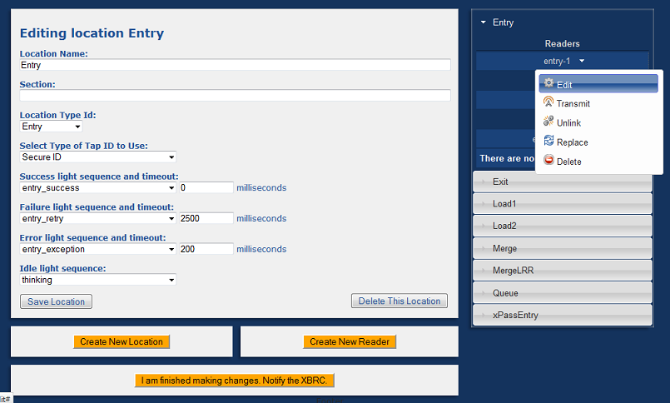

Figure 8: Location Edit Page with Reader Menu Shown

1. Make your changes in the form provided.

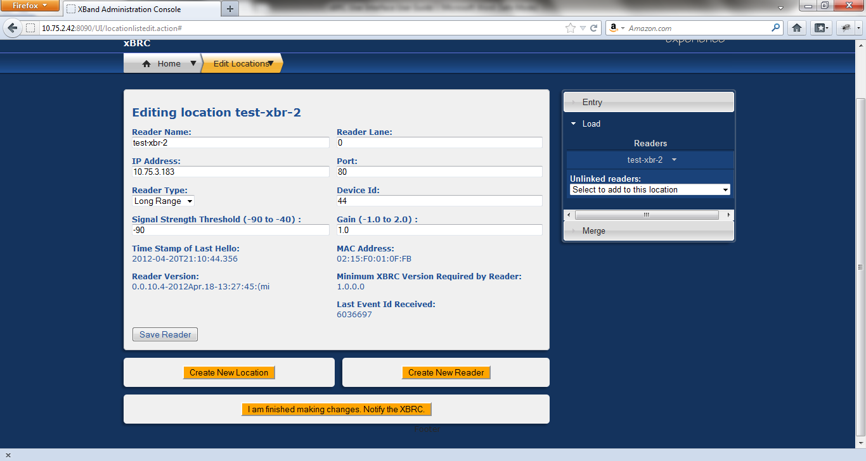

Figure 9: Reader Edit Page

1. Click **Save Reader**. Your change will be saved in the database.
2. Click **I’m finished making changes. Notify the XBRC**to force xBRC to synchronize its state with the database.

### Delete Reader

Deleting a reader removes it from the xBRC database. Deleting a reader does not remove the location it was assigned to. Next time the physical device this reader represented sends a hello message to the xBRC, a new reader will be added and placed in the unassigned readers’ bucket.

1. Navigate to the **Location Editor** page.
2. From the *accordion* menu on the right, select the location of the reader you wish to edit and then select that reader.
3. From the reader menu that appears, select **Delete***.*

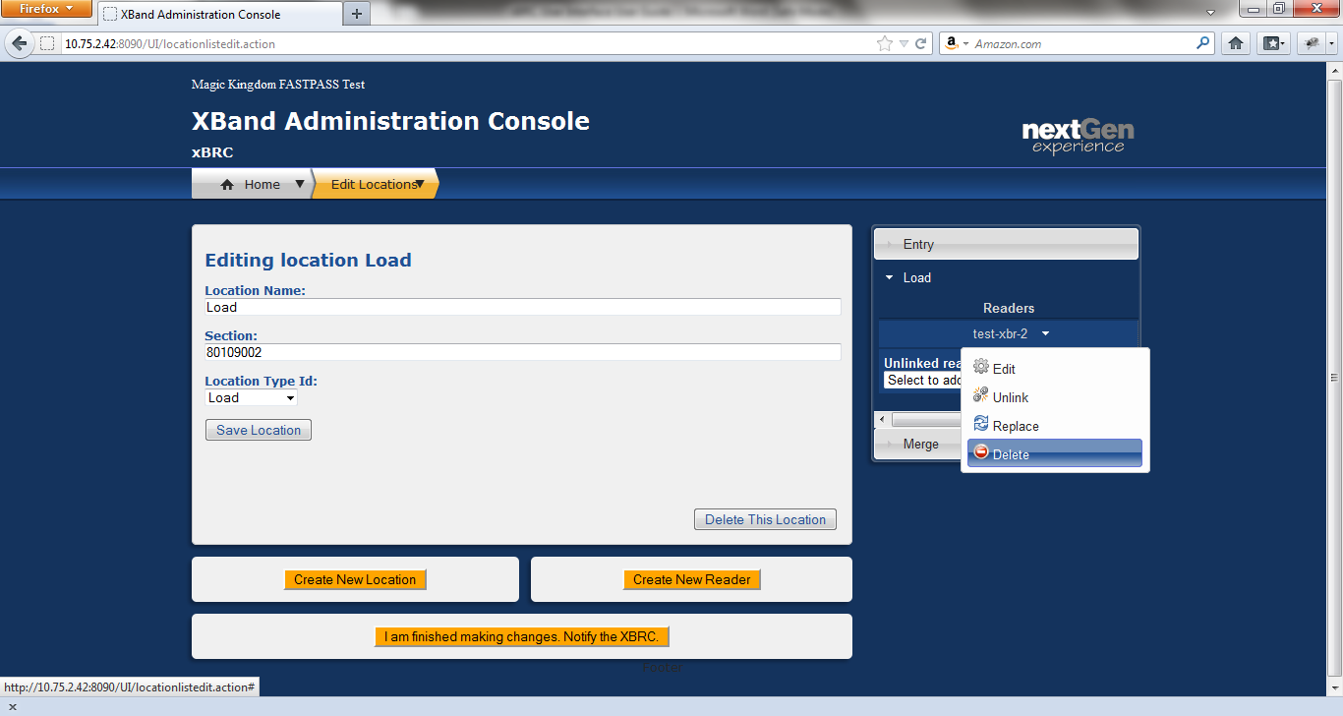

Figure 10: Location Editor Page with Reader Menu Shown

1. Click **I’m finished making changes. Notify the XBRC**to force xBRC to synchronize its state with the database.

### Unlink Reader

Unlinking a reader removes it from the location it was previously assigned to and places it in the unassigned readers’ bucket.

1. Navigate to the **Location Editor** page.
2. From the *accordion* menu on the right, select the location of the reader you wish to edit and then select that reader.
3. From the reader menu that appears, select **Unlink***.*

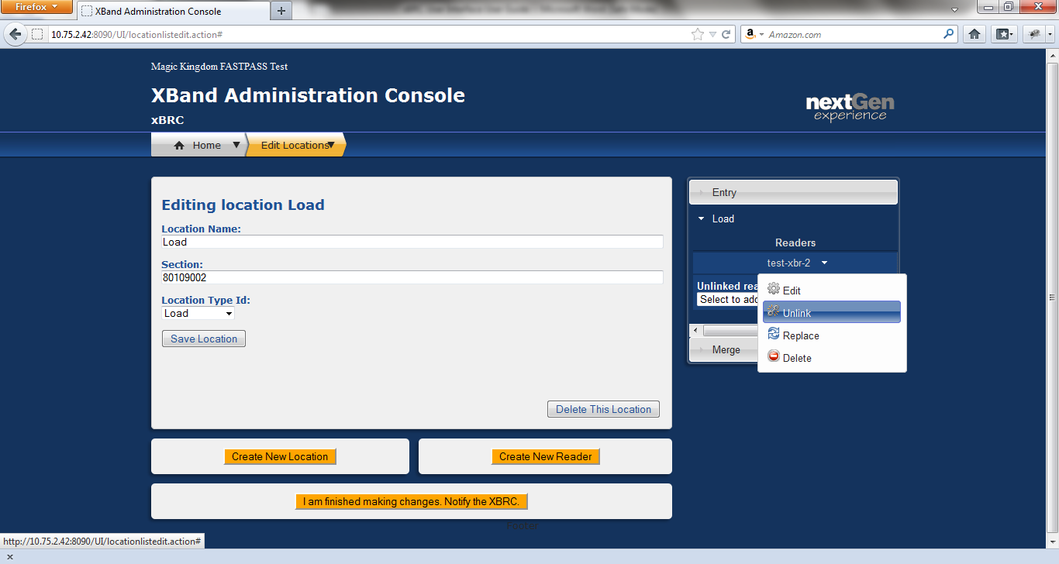

Figure 11: Location Edit Page with Reader Menu Shown

1. Your reader will appear in the unlinked readers’ bucket.

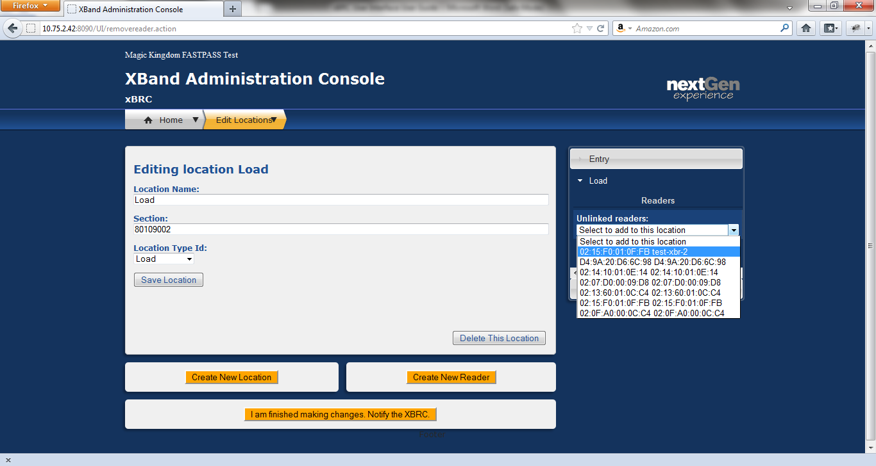

Figure 12: Unlinked Reader Showing in the Unlinked Readers' Bucket

1. Click **I’m finished making changes. Notify the XBRC**to force xBRC to synchronize its state with the database.

### Link Reader

Linking a reader means assigning it to a location. When physical readers say hello to a xBRC for the first time, they are placed in the unlinked readers’ bucket. All readers should be assigned to a location, since unlinked readers are not included in singulation.

1. Navigate to the **Location Editor** page.
2. From the *accordion* menu on the right, select the location to which you wish to add your reader.
3. Expand the **Unlinked readers**dropdown and click the reader you are adding. The reader will be added to the currently active location.



Figure 13: Unlinked Reader Showing in the Unlinked Readers' Bucket

1. Click **I’m finished making changes. Notify the XBRC**to force xBRC to synchronize its state with the database.

### Enable Transmit Functionality

Band transmit command can be configured only for xBR (long range) readers. Any xBR is capable of transmitting commands to bands.

1. Navigate to the **Location Editor** page.
2. From the *accordion* menu on the right, select the location your reader is linked to and then select that reader.
3. From the reader menu that appears select **Transmit***.*

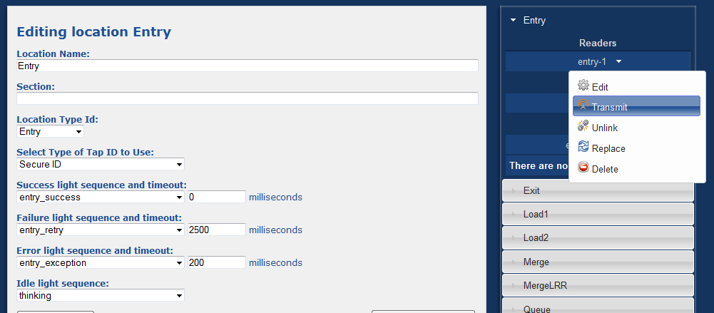

Figure 14: Location Editor Page Selecting Transmit

1. The following page will open.

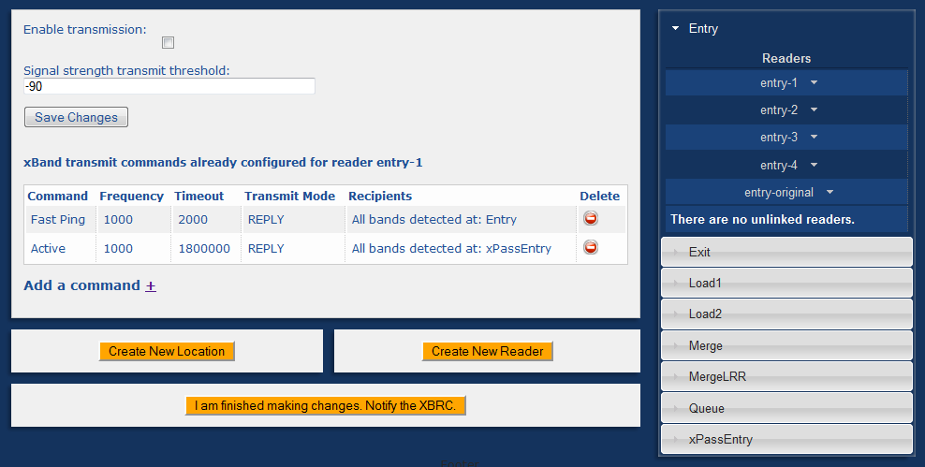

Figure 15: Selecting Enable Transmission

Check **Enable transmission** to turn this xBR into a transmitting reader.

### Disable Transmit Functionality

Band transmit command can be configured only for xBR (long range) readers. Any xBR is capable of transmitting commands to bands.

1. Navigate to the **Location Editor** page.
2. From the *accordion* menu on the right, select the location your reader is linked to and then select that reader.
3. From the reader menu that appears, select **Transmit***.*



Figure 16: Selecting Transmit

1. The following page will open.



Figure 17: Uncheck Enable Transmission

Uncheck **Enable transmission**to stop this xBR from transmitting commands to xBands. Transmit commands configured on this reader will be preserved.

### Add Band Transmit Command

Band transmit command can be configured only for xBR (long range) readers. Any xBR is capable of transmitting commands to bands.

1. Navigate to the **Location Editor** page.
2. From the *accordion* menu on the right, select the location your reader is linked to and then select that reader.
3. From the reader menu that appears, select **Transmit***.*



Figure 18: Select Transmit

1. The following page will open.



Figure 19: Transmit Options

This page allows you to do the following:

|  |  |
| --- | --- |
| **Field** | **Description** |
| *Enable transmission* | When this checkbox is checked, xBRC will send bands transmit commands defined on this reader to the reader. |
| *Signal strength transmit threshold* | Integer value between -127 and -40. Signal strength transmit threshold is different from the signal strength threshold used by xBRC for guest singulation. When a transmit command is configured to apply to all bands pinging the xBR with a certain signal strength, this is the value used. |
| *xBand transmit commands already configured* | A list of commands already configured for this reader. |
| *Add a command* | Click on the plus next to this label to configure a new command for this reader. |

The plus next to the *Add a command* link will take you to the following form:

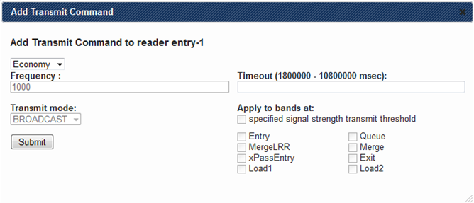

Figure 20: Form for Adding a Command

1. Using this form you can configure a new band commands as follows:

|  |  |
| --- | --- |
| **Field** | **Description** |
| *The first dropdown in the top left corner of the form* | Select a command to add. Possible choices include: *Fast Ping*, *Active*, and *Economy* in the order of a state with the highest battery consumption first. |
| *Frequency* | Tells the band either how often to wake up to listen to commands from xBR or how often to ping. |
| *Timeout* | Amount of time xBands stay in their current state before reverting to their previous state, unless the command is repeated. A band will revert from its current state to the state with a lesser battery consumption. Thus, *Fast Ping* will revert to *Active*, which will revert to *Economy*. |
| *Transmit mode* | Either BROADCAST or REPLY. In BROADCAST mode, the xBR will continuously transmit its commands to a mac address common to all bands. In the REPLY mode, the xBR transmits its commands as a reply to a ping from a band. |
| *Apply to bands at* | Band commands can either be broadcasted or send to a more controlled list of bands. A list of bands can either be comprised of all bands with specified signal strength or all bands seen at selected location(s). |

1. Click **Submit**to save your command to the database.
2. Click **I’m finished making changes. Notify the XBRC**to force xBRC to synch its state with the database.

### Remove Band Transmit Command

Band transmit command can be configured only for xBR (long range) readers. Any xBR is capable of transmitting commands to bands.

1. Navigate to the **Location Editor** page.
2. From the *accordion* menu on the right, select the location your reader is linked to and then select that reader.
3. From the reader menu that appears, select *Transmit.*



Figure 21: Location Editor Page

The following page will open:



Figure 22: Selecting the Delete Icon

1. Click the *Delete* icon next to the command you wish to remove.
2. Click **I’m finished making changes. Notify the XBRC**to force xBRC to synch its state with the database.

## Subway Diagram

All actions on the subway diagram are performed from the **Facility Designer** page accessible from the **Home** page. This page provides a flexible way of creating a graphical representation of a wide range of facilities.

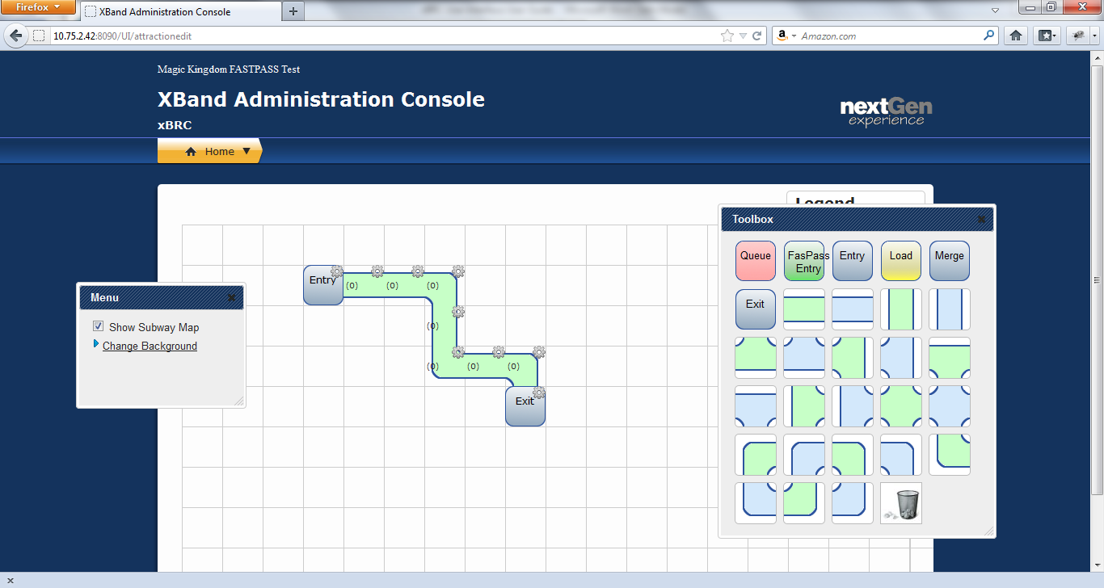

Figure 23: Facility Designer Page

### Create Subway Diagram

1. Navigate to the **Facility Designer** page.
2. Drag *location* and *path* (grid items) elements from the *Toolbox* and drop them onto the grid displayed on the page.
3. Click the icon that looks like a gear to edit the properties of each grid item.

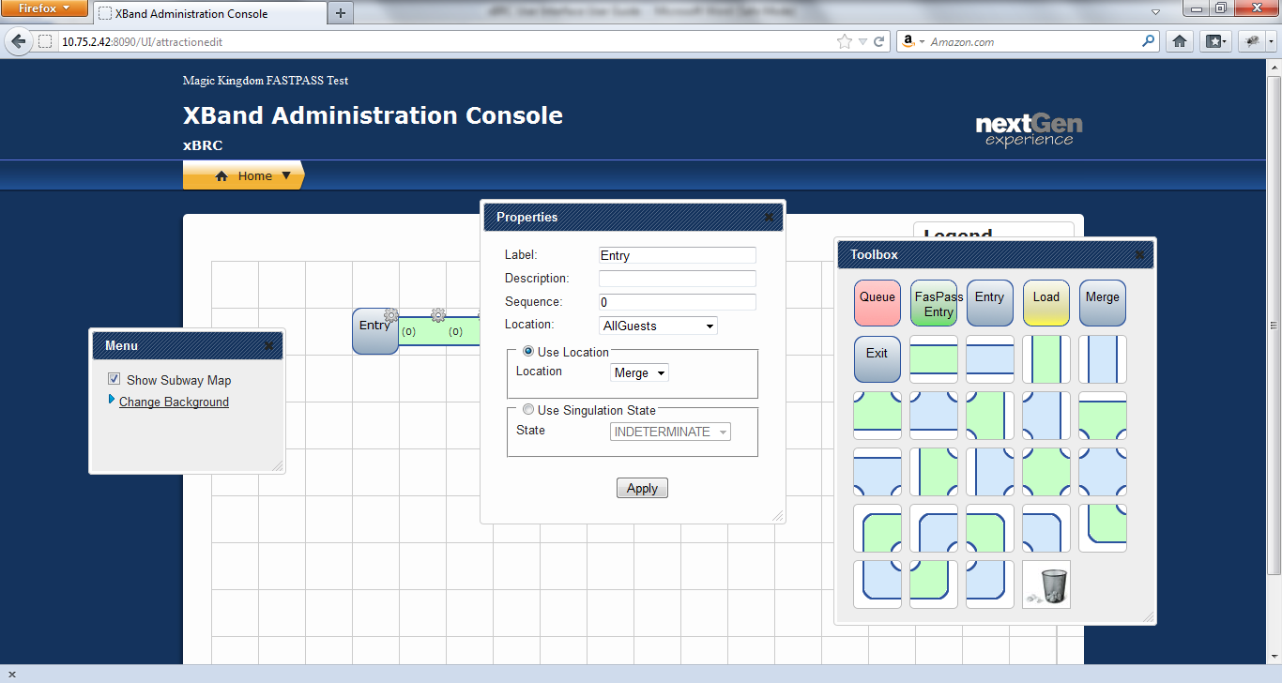

Figure 24: Grid Item Properties Popup

1. Provide the following information and click **Apply**:

| **Field** | **Description** |
| --- | --- |
| *Label* | Name of the grid item. Displays on the Facility View page. |
| *Description* | Displayed on the Facility View page. Triggered by the on hover event. |
| *Sequence* | Positioning of guest avatars in subway map. |
| *Location* | Assigns an actual location to this location grid item. |
| *Use Location* | Select this option for locations that don’t affect guests’ state changes, but you still want to show guest avatars moving through that location. |
| *Use Singulation State* | Select this option for locations that affect guests’ state changes. |

### Delete Subway Diagram

To delete a subway diagram, you must delete all grid items individually. Deleting location grid items form the subway diagram doesn’t delete the actual locations these items were representing.

1. Navigate to the **Facility Designer** page.
2. Drag *location* and *path* (grid items) elements form the grid and release them over the picture of a garbage can in the *Toolbox*.

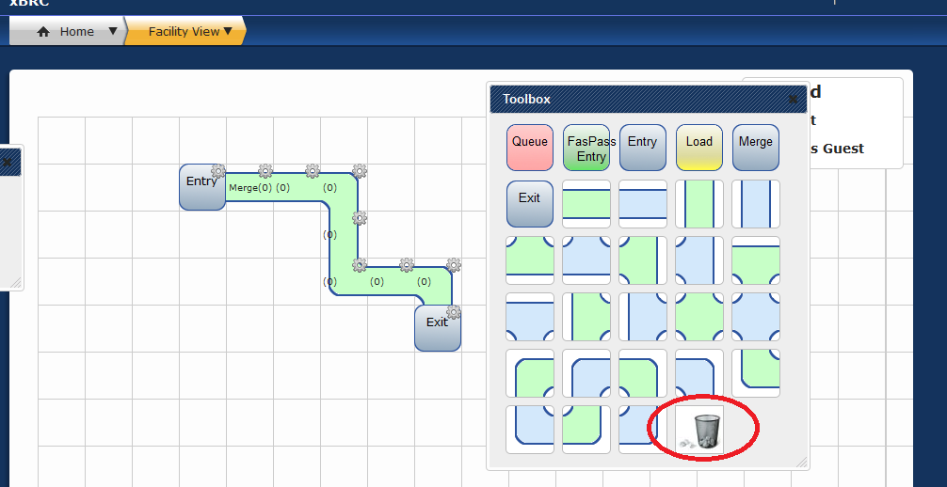

Figure 25: Facility Design Page Showing Delete Icon

### Delete Grid Item

1. Navigate to the **Facility Designer** page.
2. Drag a grid item form the grid and release it over the picture of a garbage can in the *Toolbox*.



Figure 26: Facility Designer Page Showing Delete Icon

### Add Background Image

1. Navigate to the **Facility Designer** page.
2. Click *Change Background* link located in the *Menu* box. The **Change Background** dialog will appear.

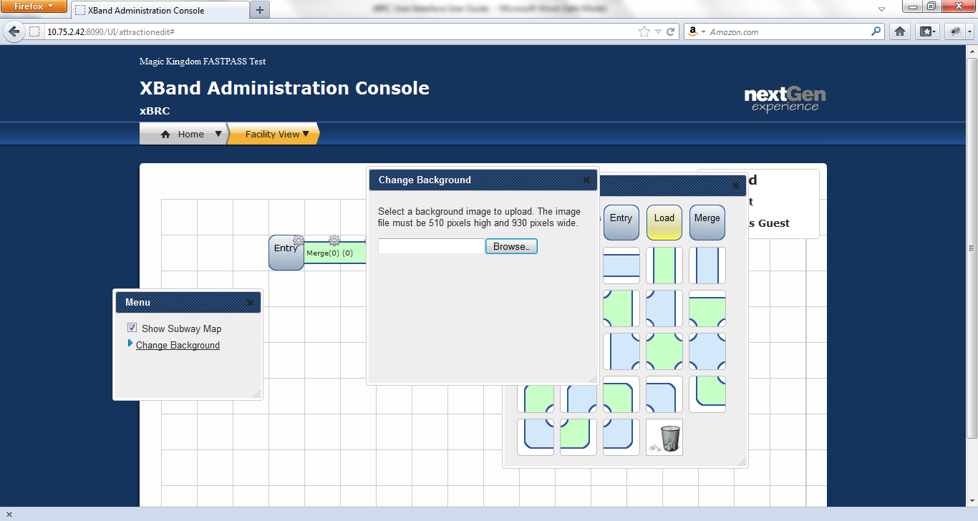

Figure 27: Facility Designer Page Showing Change Background Dialog

1. Select a background image to upload. The image file must be 510 pixels high and 930 pixels wide. The **Change Background** dialog will disappear once the image is loaded.

### Remove Background Image

1. Navigate to the **Facility Designer** page.
2. Click *Change Background* link located in the *Menu* box. The **Change Background** dialog will appear.

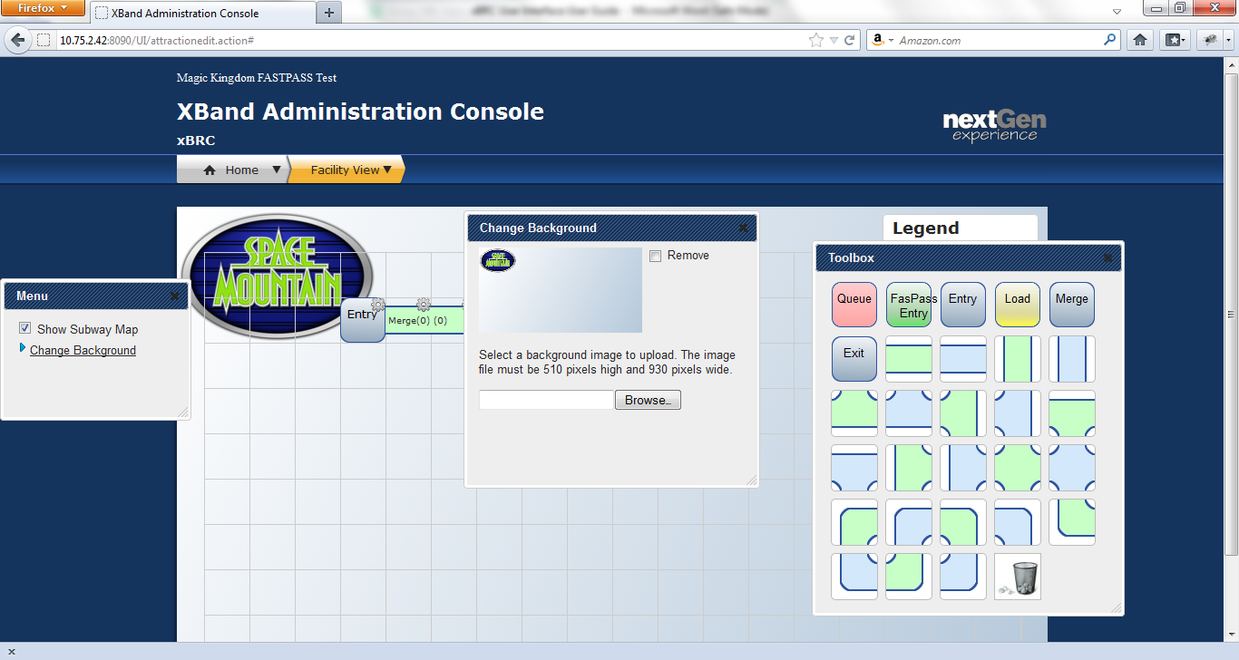

Figure 28: Change Background Dialog

1. Check **Remove**. The **Change Background** dialog will disappear once the image is deleted.

### Show Subway Diagram on Facility View Page

### Hide Subway Diagram on Facility View Page

1. Navigate to the **Facility Designer** page.
2. Check **Show Subway Map** located in the *Menu* dialog.

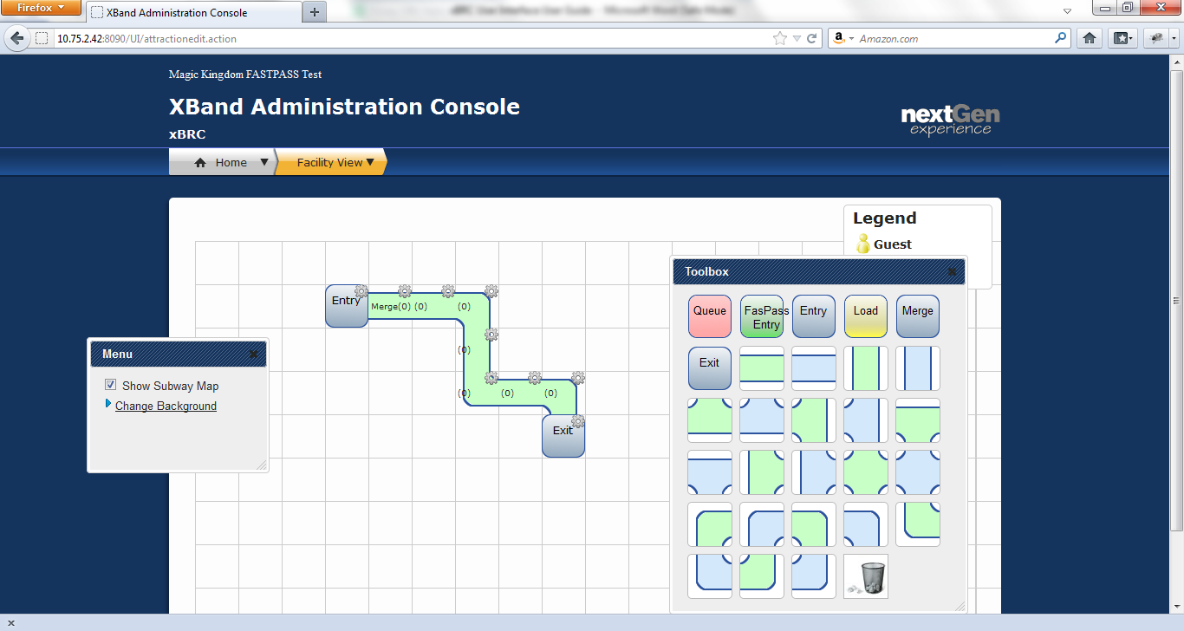

Figure 29: Show Subway Map Checkbox

## Observe Guest Moving Through Attraction

Navigate to the **Facility View** page.

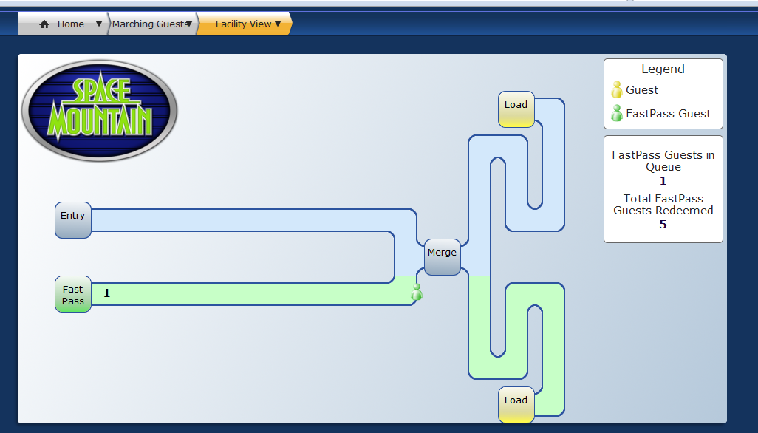

Figure 30: Facility View Page

## Observe Guest Queue Simulation

You can see simulated guests’ avatars only on the **Marching Guests** page. To see them, navigate to the **Marching Guests** page.

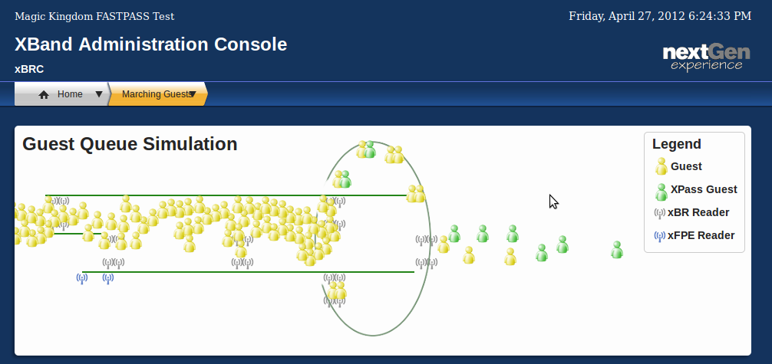

Figure 31: Marching Guests Page